**QUIZ ON**

**THE PHANTOM OF THE OPERA**

# Who does the Phantom like?

Carlotta Christine Meg

Mme Giry

# What does the Phantom wear that makes him look different?

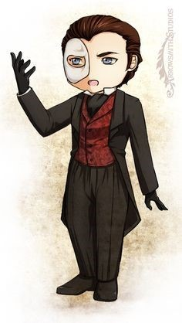A mask Gloves White shoes

A red clown nose

# Who is Christine's love?

M Andre Ubaldo Raoul

M Firmin

# Who is the best ballet dancer ?

La sorelli Madame Giry Christine Carlotta

# Who is scared off by the Phantom because he set a curse on her ?

Christine Carlotta Meg

Mme Giry

# What does the Phantom give Christine as a sign of love ?

A scarf A ring

A puppy

A necklace

# Which of the following characters die?

Mme Giry Carlotta Buquet

The Phantom

1. What is Christine's last name?

Daae Tunque Piaget Bergmann

# Is Meg Giry the daughter of Monsieur Richard?

Yes No

# Who are the new managers of the opera house?

Raoul and Buquet Christine and the Phantom Meg and Madame Giry Andre and Firmin

# What does the main female character call The Phantom?

The Phantom Lefèvre Professor Angel of Music



# What was the Phantom's background?

A child burned by acid on his face An architect from Persia

An escaped fair-ground freak

A runaway who couldn't find anywhere else to go

# What is the "room of mirrors"?

* La Carlotta's dressing room
* a trap under the opera house
* a secret part of Christine's bedroom
* the Phantom's house

# Who gets caught in the room of mirrors?

* Raoul & the Persian
* Christine & Raoul
* Carlotta & her pet dog
* Just Raoul

# What is the first thing that happens in the room of mirrors?

* It gets freezing cold.
* It gets burning hot.
* It fills with water.
* It fills with sand.

# Who is the "Opera Ghost"?

* a name used by the Phantom to sign letters
* a pen-name used by the Phantom when he writes operas
* a character played by La Carlotta in a show
* the name of a show

# What is a chandelier?

* 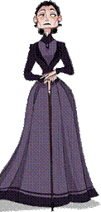a type of French cookie
* a type of dog that Carlotta likes
* a special kind of hairstyle
* a big light in the middle of the opera house

# What happens to the chandelier?

* Raoul uses it to swing across the opera house.
* The Phantom makes it fall on the audience.
* Christine cleans it each morning.
* The opera house owners don't like it so they buy a new one.

# What does the Phantom ask the owners to do?

*  Pay him 20,000 francs a month, keep Box 5 for him, and don't let Carlotta sing.
*  Pay him 20,000 francs a year, leave him alone, and don't let Christine sing.
*  Get rid of Raoul, pay him 50,000 francs a month, and keep Box 2 for him.
* Let him go on a dinner date with Carlotta.

# What is the name of the author of the book ? Gaston Leroux

**OPINION: Did you like the story ? Why ?**

I liked this book more than I thought, at first I didn't like it very much but over time I liked it more. It is a book that I recommend if you like mystery.

