Gastón Louis Alfred Leroux

# Gaston Leoux

FULL NAME

6 May 1868

BIRTH DATE

Paris, France

BIRTH PLACE

# Fill in t e FBI’s file fo te suspect Gaston Le oux

Paris, Normandy

RESIDENCE

PROFESSION: Journalist and novelist

5,9 ft/ 1,80m

Dominique Alfred Leroux and Marie Bidault

PARENTS :

GASTONLEROUX

80 kg

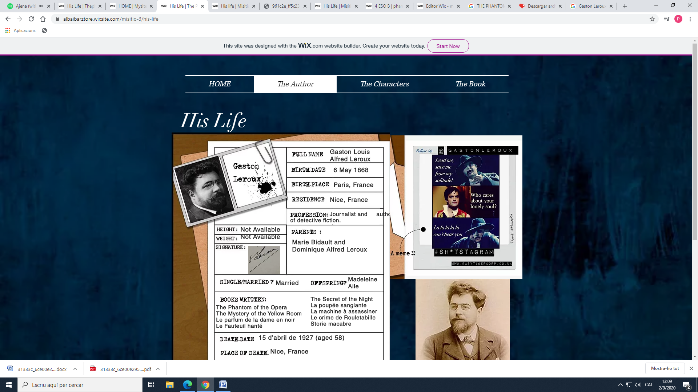

SINGLE/MARRIED ? OFFSPRING?

Married to Marie Lefranc

Madeleine Aile

BOOKS WRITTEN:

-La machine à assassiner

-The Mystery of the Yellow Room

-Le parfum de la dame en noir

-Le Fauteuil hanté

-Le crime de Rouletabille

-Storie macabre

-The Secret of the Night

-La poupée sanglante

-The Phantom of the Opera

DEATH DATE PLACE OF DEATH

April 15th, 1927

Nice, France

Cimetière du Château

A meme !!

PLACE OF TOMB

