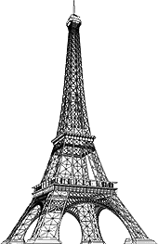

***Paris in the Belle Époque***

**Paris in the Belle Époque was a period in the history of the city between the years 1871 to 1914, from the beginning of the Third French Republic until the First World War.**

**It saw the construction of the Eiffel Tower, the Paris Métro, the completion of the Paris Opera, and the beginning of the Basilica of Sacré-Cœur on Montmartre.**

**Three "universal expositions" in 1878, 1889 and 1900 brought millions of visitors to Paris to sample the latest innovations in commerce, art and technology.**

**Paris was the scene of the first public projection of a motion picture, and the birthplace of the Ballets Russes, Impressionism and Modern Art.**

**The expression Belle Époque ("beautiful era") came into use after the First World War; it was a nostalgic term for what seemed a simpler time of optimism, elegance, and progress.**

**WHY ARE THESE PLACES IMPORTANT? JUST WRITE A SIMPLE SENTENCE EXPLAINING WHY THEY ARE SO FAMOUS ALL OVER THE WORLD.**

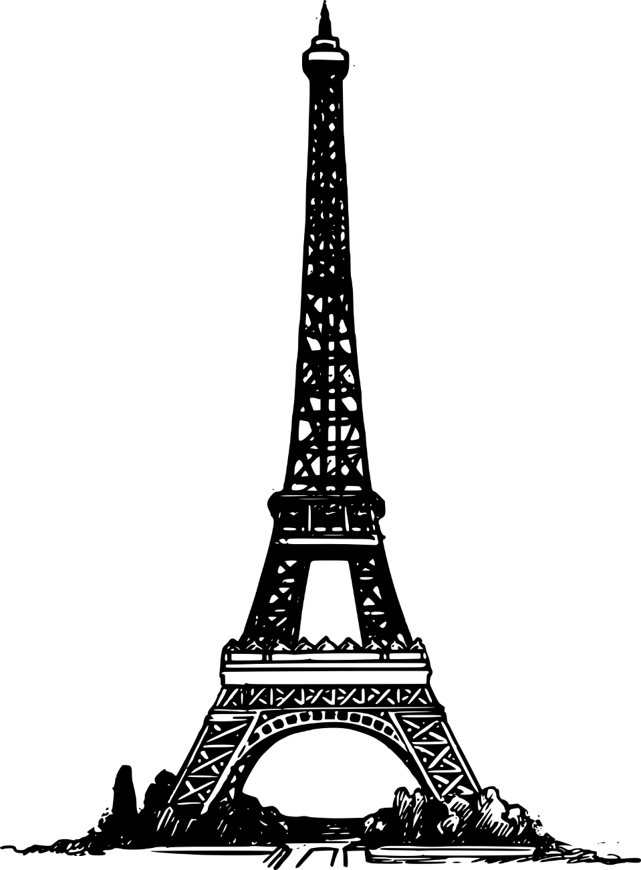

**SPOT THE FOLLOWING PLACES ON THE MAP AND MARK THEM.**

1. **THE OPERA HOUSE**
2. **THE EIFFEL TOWER**
3. **THE SACRE COEUR**
4. **NOTRE DAME**
5. **THE PANTHEON**
6. **ARC DE TRIOMPHE**
7. **LES INVALIDES**
8. **MUSÉE DE CLUNY**
9. **PLACE RÉPUBLIQUE**
10. **CEMETERY PÈRE LACHAISE**

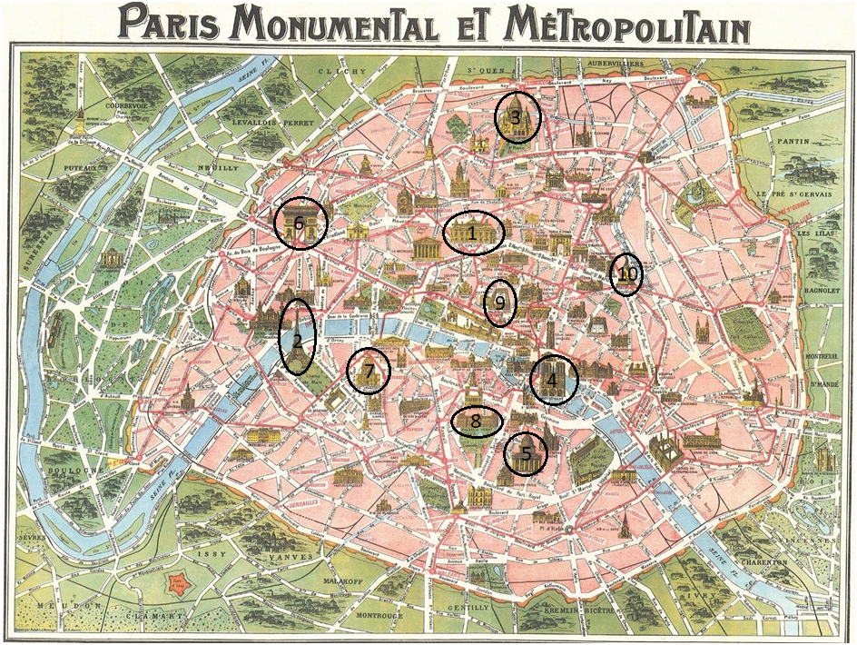

**1.THE OPERA HOUSE🡪** The Palais Garnier is an opera house located in the 9th arrondissement of Paris. Built between 1861 and 1875, the Palais Garnier was commissioned by Emperor Napoleon III and has gone on to become as important a symbol to Paris as the Eiffel Tower.

**2.THE EIFFEL TOWER🡪** For 130 years, the Eiffel Tower has been a powerful and distinctive symbol of the city of Paris, and by extension, of France. At first, when it was built for the 1889 World's Fair, it impressed the entire world by its stature and daring design, and symbolized French know-how and industrial genius.

**3.THE SACRE COEUR🡪** Sacre Coeur is a double monument, political and cultural, both a national penance for the defeat of France in the 1871 Franco-Prussian War and the socialist Paris Commune of 1871 crowning its most rebellious neighborhood, and an embodiment of conservative moral order, publicly dedicated to the Sacred Heart of Jesus.

**4.NOTRE DAME🡪** Paris Cathedral played an important role in religious and secular life. As the seat of the bishop, Notre Dame was the most significant religious building in the city. Its size and luxury symbolized the power of the church and the authority of the bishop.

**5.THE PANTHEON🡪** The Panthéon was reconsecrated and resecularized several times during the 19th century, serving as a church in 1828–30 and in 1851–70. Today it is a civic building that serves as a repository for the remains of great French citizens.

**6.ARC DE TRIOMPHE**🡪 The Arc de Triomphe honours those who fought and died for France in the French Revolutionary and Napoleonic Wars, with the names of all French victories and generals inscribed on its inner and outer surfaces. ... Beneath its vault lies the Tomb of the Unknown Soldier from World War I.

**7.LES INVALIDES🡪** Because of its location and significance, the Invalides served as the scene for several key events in French history. On 14 July 1789 it was stormed by Parisian rioters who seized the cannons and muskets stored in its cellars to use against the Bastille later the same day. Napoleon was entombed under the dome of the Invalides with great ceremony in 1840.

**8.MUSÉE DE CLUNY🡪** The building itself is a rare extant example of the civic architecture of medieval Paris. It was formerly the town house of the abbots of Cluny. The first Cluny hôtel was built after the Cluny order acquired the Ancient thermal baths in 1340. Alexandre du Sommerard did a public museum ato preserve relics of France's Gothic past.

**9.PLACE RÉPUBLIQUE🡪** The square was originally called the Place du Château d'Eau, named after a huge fountain designed by Pierre-Simon Girard and built on the site in 1811. The square took its current shape as part of Baron Hausmann's vast renovation of Paris. Haussmann also built new barracks on the cities, to garrison troops useful in times of civil unrest.

**10.CEMETERY PÈRE LACHAISE🡪** The cemetery of Père Lachaise opened in 1804 and takes its name from the confessor to Louis XIV. The property, situated on the hillside from which the king watched skirmishing between the armies of the Condé and Turenne during the Fronde, was bought by the city in 1804.