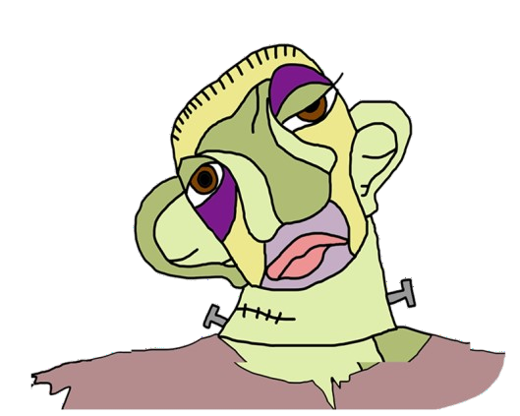MONSTERS

|  |  |  |  |
| --- | --- | --- | --- |
|  | **THE MONSTER**  **OF VICTOR FRANKENSTEIN** | **QUASIMODO** | **THE ELEPHANT MAN** |
| **REAL PERSON OR CHARACTER ?** | Character | Character | Real Person |
| **WHO CREATED HIM?** | Mary Shelley | Victor Hugo | His parents: Joseph Rockley and Mary Jane Morrick |
| **WHEN ?** | 1818 | 1831 | He was born in 1862. |
| **BOOK HE BELONGS TO** | Frankenstein | The hunchback of Notredame |  |
| **HIS PROBLEM** | He wanted to be good, but his appearance frightened people and they treated badly him. | He fell in love with a girl who couldn't be with her. | He had Proteus syndrome, which causes excess growth in the organs. He had deformed body parts. |
| **COULD HE BE HAPPY?** | No, he couldn’t. | Yes, in the end he could. | No, he couldn’t. |
| **HOW DID HIS LIFE END?** | The Monster commits suicide. | He starves to death next to her lover’s grave. | He died of asphyxia in his sleep. |